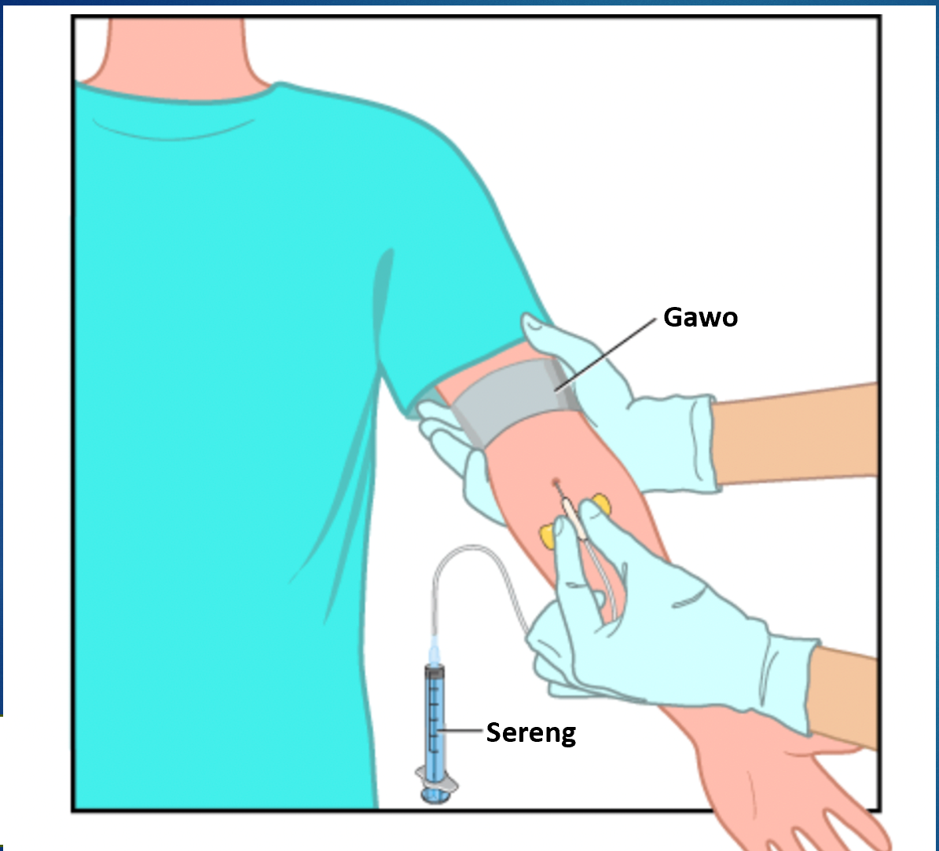

SOCIAL STORY:

Prelèvman San: Sa mwen dwe konnen

Pwojè sou Aksè ak Swen Sante pou Maladi Otis Posib gras ak C.J.L. Foundation
A note to caregivers:

This social story is intended to support your loved one in completing a blood draw at Mass General Hospital or any other clinic or hospital setting. The steps may vary depending on your loved one’s medical history and needs. As such, not all sections may apply to your loved one. For any specific concerns, please reach out to your medical provider to discuss prior to your loved one’s procedure.

You know your loved one the best. This social story was created as a tool to aid in preparing an individual for their upcoming blood draw. We recommend that you read this first and choose what information you think will be helpful. Please feel free to use and modify this in conjunction with language and other tools your loved one is familiar with. For instance, the phrase “First Blood Draw, Then Home” may be modified to include a different location or enjoyable activity that could be done after the blood draw is complete. Please modify images of relevant doctors, support persons, and coping strategies to sure it is individualized to your loved one’s needs.

Some tips for preparation and use of the social story include the following:

- Revize davans. Panse pou w revize istwa sosyal la pou ou menm oubyen avèk moun ki pwòch ou depi avan yo fè prelèvman san an pou ou. Sa pèmèt ou pran tan pou w analize atant yo, idantifye difikilte ki ka genyen yo epi jwenn solisyon pou diminye anksyete. Kapab gen nesesite yon pratik siplemantè, kidonk revize davans lan enpòtan.
- Pèsonalize. Chak moun ka bezwen yon kantite enfòmasyon diferan oubyen ka prefere resevwa yon kantite enfòmasyon diferan, se poutèt sa ou dwe deside ki enfòmasyon ki pi itil pou ou menm oubyen pou pwòch ou a. Ajoute foto oubyen enfòmasyon espesifik pou ou menm/pwòch ou a (pa egzanp: foto doktè a, moun k ap sipòte w la, distraksyon prefere). Gen plizyè pati nan istwa a kote yo kapab modifye epi pèsonalize enfòmasyon yo. Pou moun ki gen pwoblèm koyitif oubyen pwoblèm kominikasyon, panse itilize dyapozitif 4-5, 13, 20 – 27.
- Idantifye Estrateji Adaptasyon yo. Chèche estrateji adaptasyon yo endike an jòn yo nan tout istwa a. Idantifye zouti ki ka ede w diminye anksyete. Distraksyon an se premye estrateji pou diminye anksyete ki gen rapò ak pwosedi medikal yo.
- Eksprime w. Se ou ki pi byen konnen bezwen w yo ak bezwen pwòch ou a. Mande sa ou bezwen pou prelèvman san an ka byen pase. Pafwa sa ka gen ladan itilizasyon sipò vizyèl pou montre chak etap, pran radevou pou pèmèt yon moman ki pa gen twòp aktivite ladan pou diminye tan atant lan, pa mete pansman an, mande yon doktè pou preskri w medikaman kont anksyete ak/oubyen krèm EMLA pou anestezi po a, epi fikse yon limit pou fè yon poz oubyen sispann prelèvman san an si ou menm/pwòch ou a gen yon gwo anksyete oubyen yon konpòtman ki fè eksperyans lan vin reprezante danje (pa egzanp atrap egwi sereng lan). Panse fè yon lis kesyon ou menm oubyen pwòch ou a ta renmen poze doktè a oubyen ekip medikal la konsènan prelèvman san an oubyen rezilta ki lye avèk li yo.
- Egzamine atant yo ak pratik yo. Fè efò pou w revize sa ki pral pase pandan prelèvman san an. Egzamine etap pou w fè prelèvman san an epi detèmine aspè nan pwosedi a ki ka ogmante anksyete. Sa ka pèmèt elaborasyon estrateji ki ka itil (pa egzanp, itilize distraksyon pandan etap ki lakòz plis anksyete yo, itilize yon adezif nan plas yon pansman, mete rad ki gen manch kout). Fè pratik davans sou etap prelèvman san an. Familyarize w ak materyèl yo (pa egzanp: gawo, gan, twal alkòl, egwi papiyon pou fè prelèvman san an kote yo retire epi yo mete yon lòt aparèy nan plas egwi a) epi pratike etap k ap dewoule pandan y ap fè prelèvman san an pou toutbon an. Pandan pratik la, avanse ak ti etap yo pou w pèmèt moun nan rete alèz pandan l ap familyarize l ak materyèl nesesè pou fè prelèvman san an. Fè pratik pou w rete san bouje pandan anviwon 3 minit, pandan w ap itilize yon minit pou w raple w tan ki pase a ak tan moun nan rete pou l fè san li pa bouje a.

For some, it can additionally be helpful to practice modifications of these steps at home or come for a pre-visit tour.

We understand that coming to the doctor and undergoing a procedure can be stressful. Please bring any comfort items you feel your child would benefit from.

We are committed to ensuring both you and your child have the best experience possible. Please do not hesitate to let us know how we can best support you and your child.

Sincerely,

M pra l fè prelèvman san m lan nan

___________________________________
(kote a)

nan dat

_____________________.
(dat)

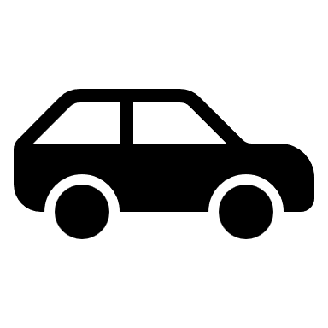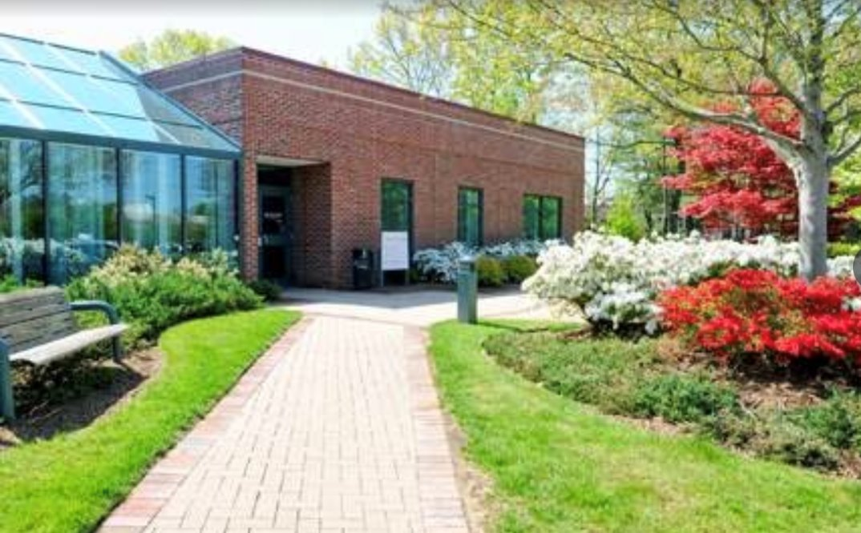

(Insert picture of location)

M ka santi m estrese, men sa pa grav paske gen yon manm nan fanmi m/yon moun k ap bay swen k ap akonpanye m.

M p ap poukont mwen.

________________ ap vini avèk mwen.

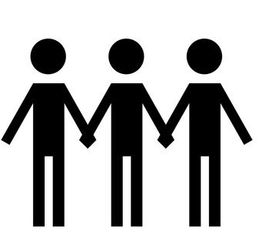
(antre foto moun k ap ba w sipò a)

Premyèman, m pral fè prelèvman san an, aprè sa m ap antre lakay mwen.

PREMYÈMAN  PRELÈVMAN SAN | APRÈ SA  LAKAY  OUBYEN _______________  (antre aktivite prefere a)
 | 
Poukisa m dwe fè yon prelèvman san?

Doktè rekòmande pou fè yon prelèvman san anviwon 1 fwa chak ane.

Se yon pwosedi enpòtan ki pèmèt doktè a gen plis enfòmasyon sou fonksyònman kò m yon fason pou yo asire yo mwen an sante.

Doktè yo ak syantifik yo kolekte san an nan yon tib.
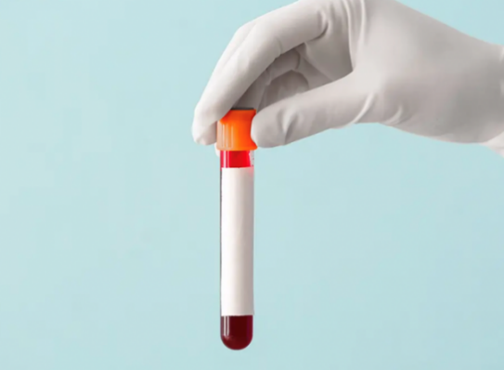
Chak selil nan kò nou gen yon fonksyon diferan ki gen yon enpak sou fonksyònman kò nou.

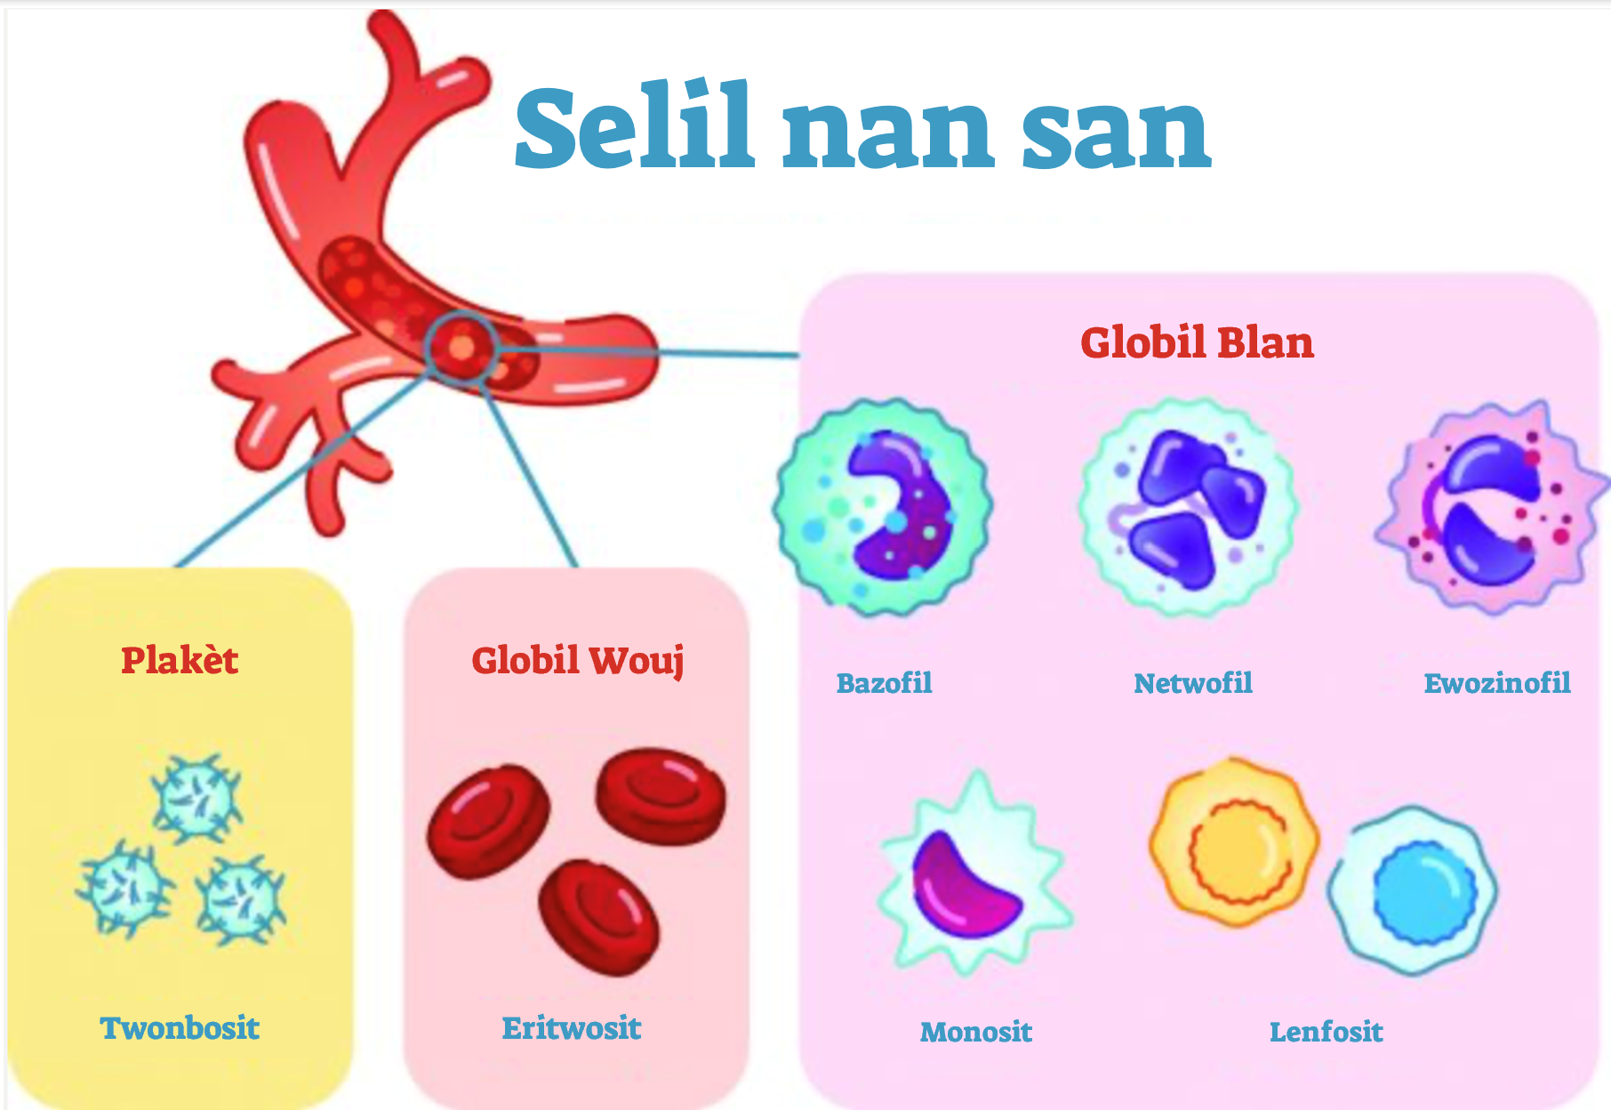

I can learn more about blood draws at:

- What You Need to Know About Blood Testing: MedlinePlus Medical Test
- Blood Draw Video
Yon prelèvman san kapab bay plis enfòmasyon pou ede m, pa egzanp pèmèt doktè m lan fè yon dyagnostik oubyen dekouvri si m dwe modifye alimantasyon m oubyen medikaman m ap pran yo.

Fè yon dyagnostik   | Eksplike sentom yo, tankou si m santi m fatige oubyen malad  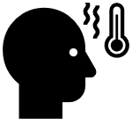
Verifye si medikaman yo oubyen tretman yo efikas  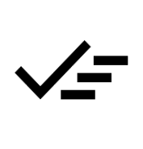 | Kontwole sante m oubyen eta sante m  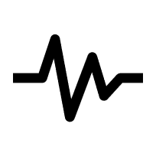
Dekouvri si m dwe modifye rejim alimantè mwen oubyen si m dwe pran medikaman
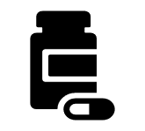

Mwen ka santi m estrese oubyen pè. Sa a nòmal.
Si m santi m pè, mwen kapab:

Fè yon moun konnen kijan m santi m | Poze enfimyè m lan oubyen doktè m lan  yon kesyon | Respire afon
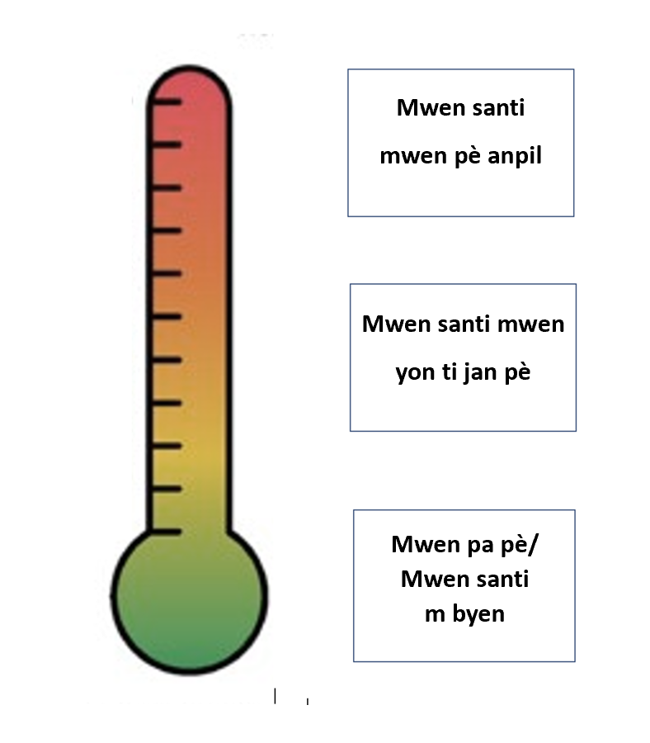 |  | 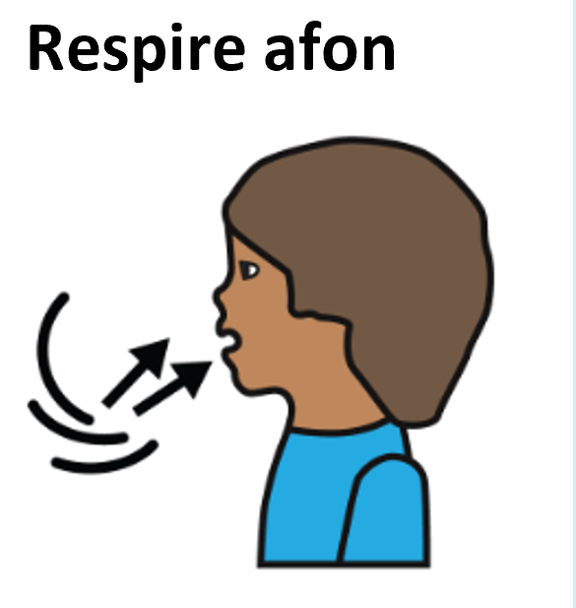
Panse ak yon bagay ki amizan mwen pral fè lè m fini | Gade yon videyo oubyen kèk foto | ____________  (Lòt)
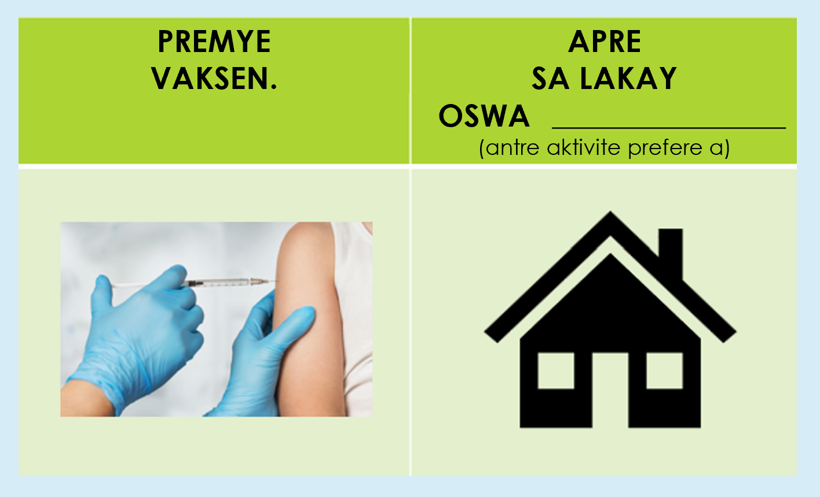 | 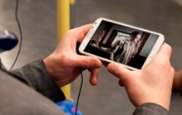

I can tell someone how I am feeling.

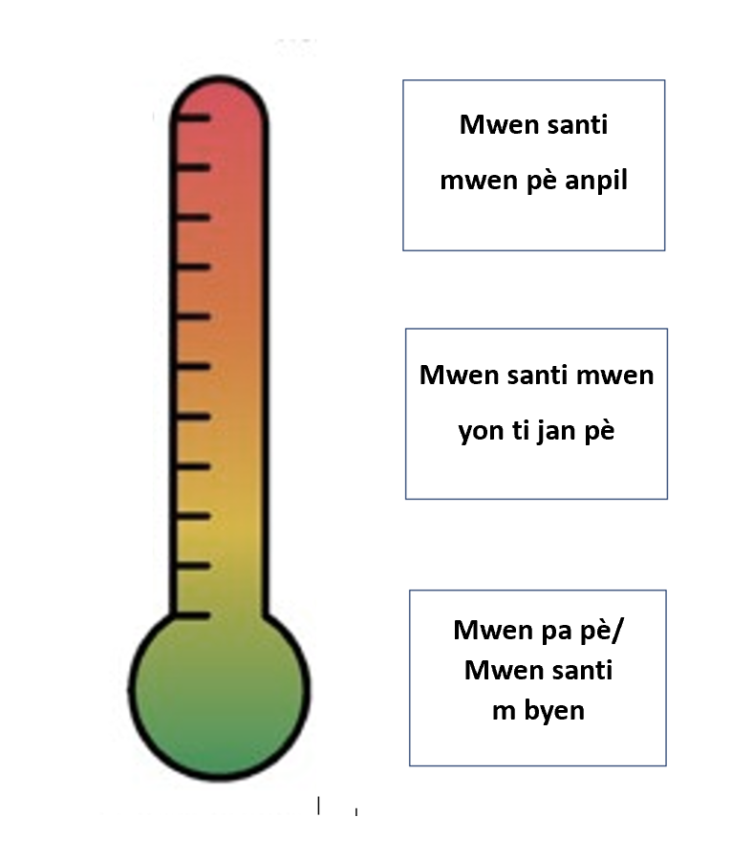

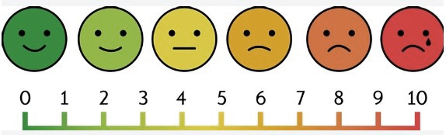
Kòman pou m prepare m pou yon prelèvman san?

Avan prelèvman san an li enpòtan pou m konnen sa k pral pase.

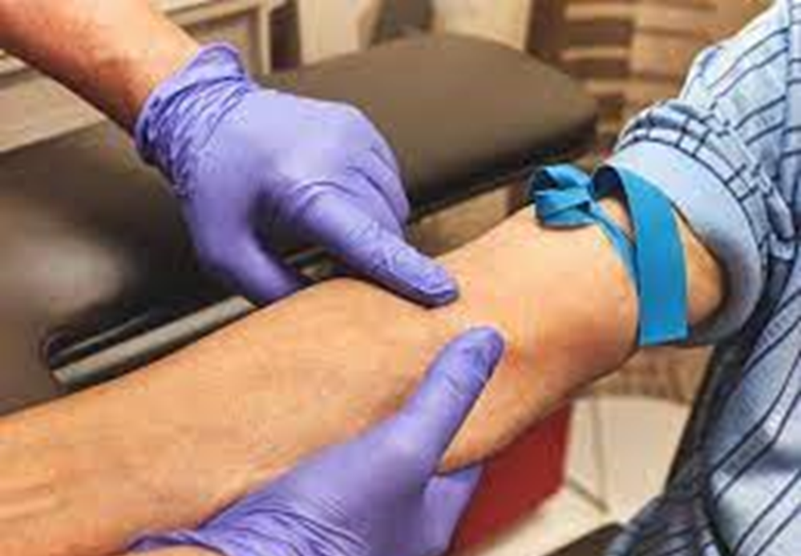

To get ready for my test, I can look at pictures and watch videos of blood draws.

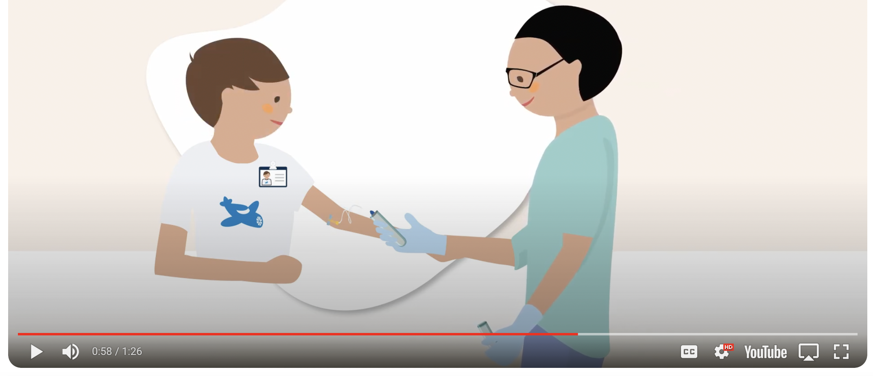
Blood Draw Video

Mwen ka gade kèk foto sou yon prelèvman san ak videyo yon moun k ap sibi yon prelèvman san.

Lè m pale de sa m santi, sa ka ede mwen menm/fanmi m/moun k ap ban m swen an elabore yon plan.

Si m estrese konsènan:
Retwouse manch rad mwen | Mwen kapab mete rad ki gen manch kout  
Gawo a | Mwen kapab fè pratik epi eseye imajine "se yon kalen l ap bay bra m."
Gade egwi a | Mwen ka vire je m lòt kote  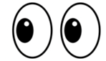
Pansman | Mwen ka mande yon bandaj adezif ki p ap kole sou po m  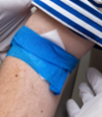
Aprè sa, m ka al gade kèk foto espas kote m pral sibi prelèvman san an.

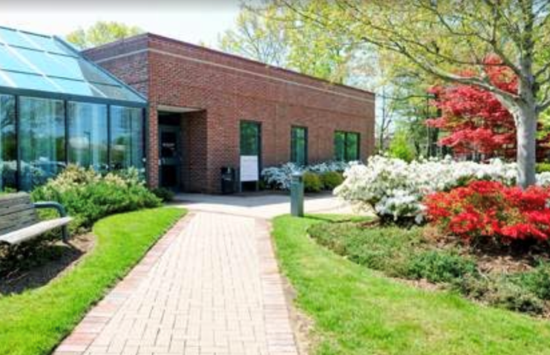



Pafwa, m ka al vizite espas la avan m al sibi prelèvman an pou m ka santi m pare.

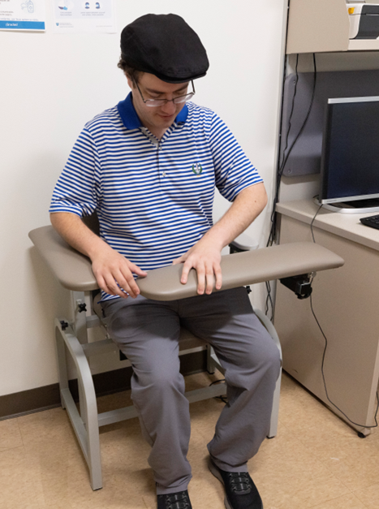

Si m ap fè pratik pou yon prelèvman san lakay mwen, m ka pa pè oubyen pa estrese menmjan.

Mwen ka fè pratik sou yon manm nan fanmi m oubyen sou yon zanmi epi mande l pou l fè
pratik sou mwen.

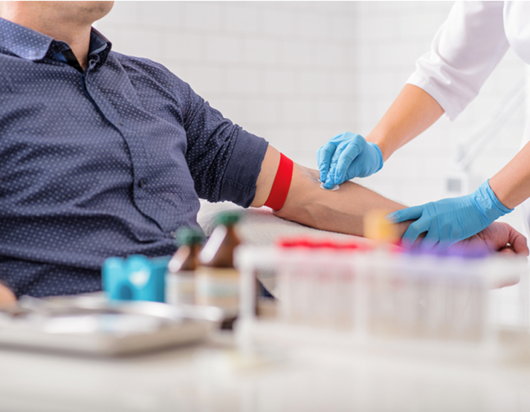

Mwen dwe fè pratik pou m rete san bouje pandan anviwon 3 minit.

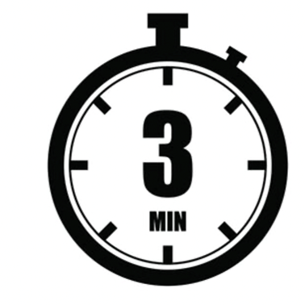

Yon kwonomèt ka ede m pou m sonje konbyen tan mwen dwe rete san bouje a.

(Kontè Envèse Vizyèl)
Gen plizyè bagay mwen kapab fè pou m prepare m pou jou prelèvman san an.
I can:
  Bwè anpil dlo |   Mete rad ki gen manch kout
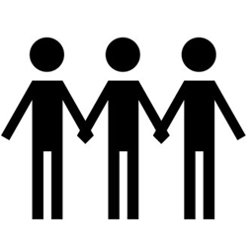  Fè yon moun akonpanye w pou l ba w sipò | 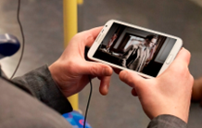    Vini ak bagay pou Distraksyon
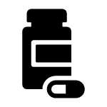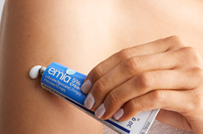
Mande doktè m lan si m bezwen medikaman ak/oubyen krèm anestezi
Si mwen gen kesyon oswa si mwen vle defann sa m bezwen, mwen ka ekri yo epi mande doktè m lan, enfimyè m lan oswa flebotomis mwen an esplikasyon sou yo avan yo pran san mwen.

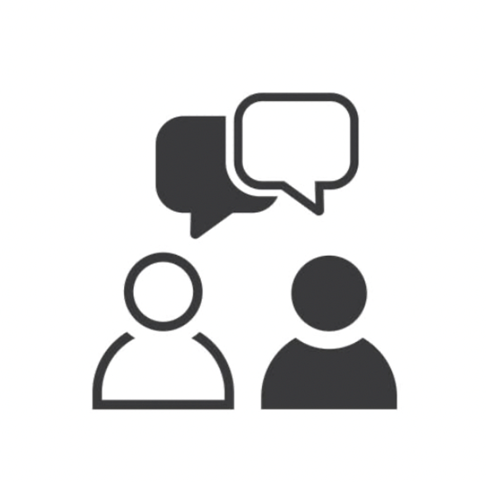
Kesyon mwen ta renmen poze doktè/enfimyè mwen an:
1.

2.

3.

Kisa k ap pase jou y ap fè prelèvman san mwen an?

M ap rive nan klinik lan pou m fè prelèvman san mwen an.

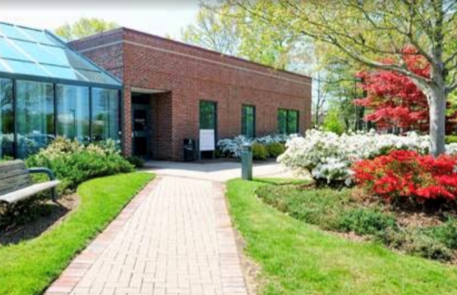

M ap anrejistre nan resepsyon an. Mwen ka vini ak yon moun pou sipòte m pou ede m santi m konfòtab.

M ap tann nan sal datant lan jiskaske yo site non m.



Mwen ka vini avèk yon aktivite mwen renmen fè pou m itilize antanke yon distraksyon pandan m ap tann lan.

Lè enfimyè a site non m, m ap retounen nan sal egzamen an epi m ka fè moun ki pou sipòte m lan antre avè m si m vle.
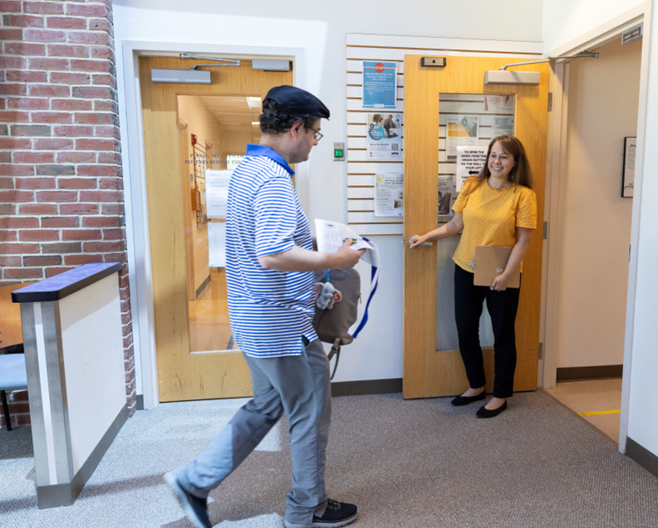

M ap chita sou chèz prelèvman san an. Mwen ka fè enfimyè mwen an konnen si mwen gen kesyon.

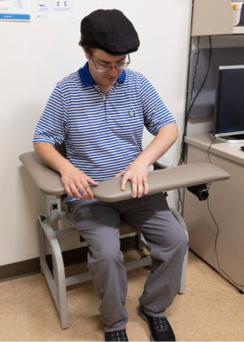
Mwen ka kòmanse pran plezi nan bagay mwen te pote pou distraksyon an.

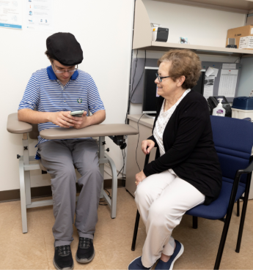

Mwen dwe poze bra m sou chèz la pou enfimyè a ka gade epi santi venn mwen yo.

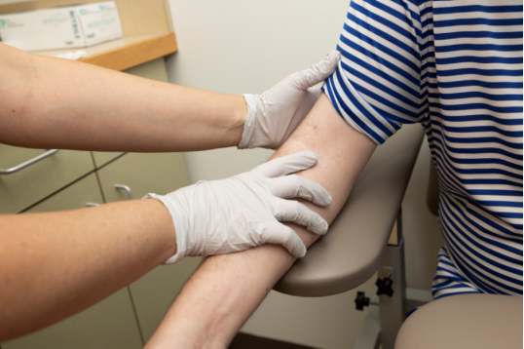

Enfimyè a pral mete gan epi mare gawo a nan bra mwen. Gawo a antoure bra mwen epi m santi l tankou l sere.

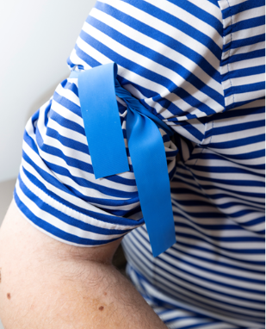

Apre sa, enfimyè a pral netwaye bra mwen ak yon ti koton ki gen yon ti alkòl ladan l.

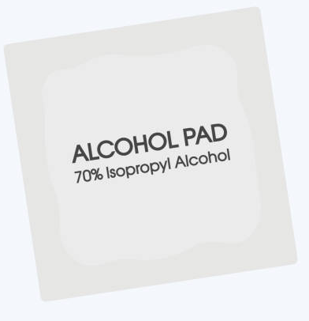
Ou ka santi l mouye, li frèt epi l gen yon sant ki fò.

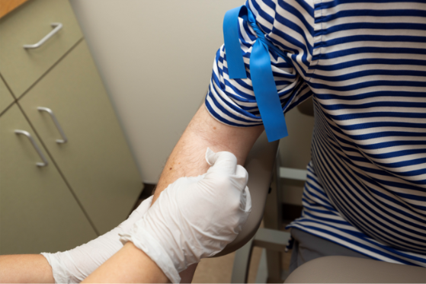

Enfimyè a ap mete egwi a nan bra mwen. Li tankou yon ti pensman oswa yon ti doulè.

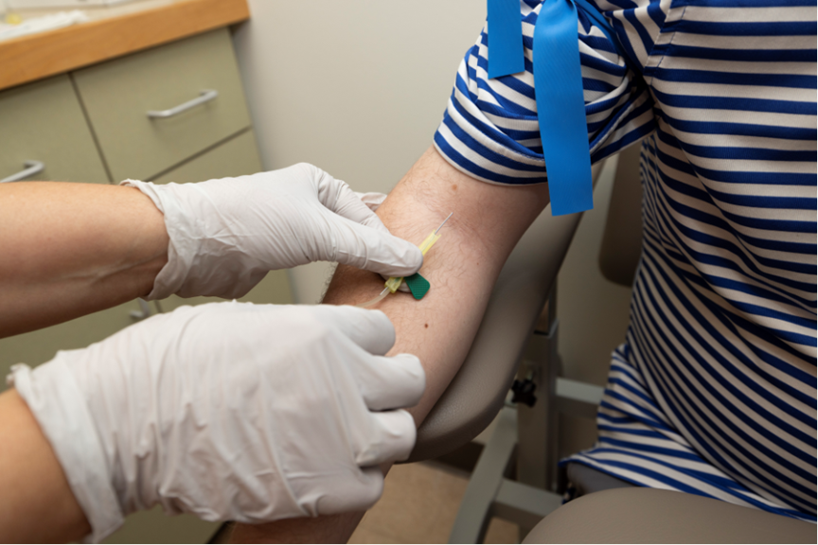
If I feel nervous, I can:

Fè yon moun konnen kijan m santi m | Poze enfimyè m lan oubyen doktè m lan  yon kesyon | Respire afon
Panse ak yon bagay ki amizan mwen pral fè lè  m fini | Gade yon videyo oubyen kèk foto | Pa gade egwi a

Mwen ka kenbe men moun sipò mwen an si mwen vle.

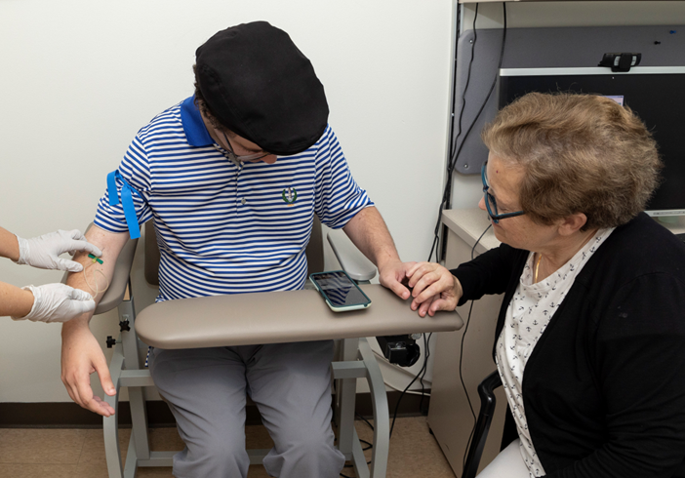

M ap rete trankil pou anviwon 3 minit Map fini byen rapid. Mwen ka sèvi ak yon kwonomèt pou fè m sonje konbyen tan mwen bezwen rete trankil.

Enfimyè mwen an ap retire gawo mwen an. Aprè yon ti tan, enfimyè mwen an ap retire egwi a. Mwen prèske fini!

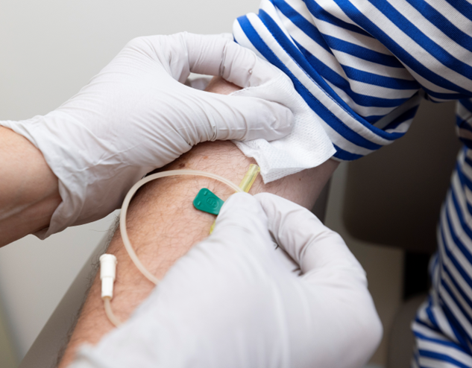

Enfimyè mwen an oswa flebotomis mwen an ap mete yon twal gaz ak yon bandaj adezif oswa yon pansman sou bra mwen.

Mwen fini nèt epi mwen pare pou m ale lakay mwen!

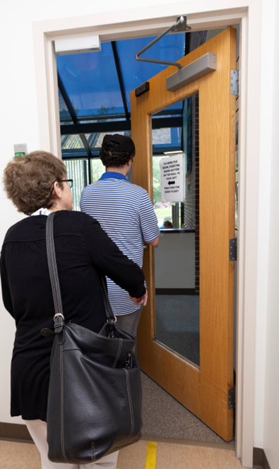

It is great I did something to keep me healthy and strong!

My blood draw is ALL DONE!
It was good I did something that helps me to stay healthy!

Doktè mwen an, ___________________, pral pale avè m ak fanmi mwen sou rezilta yo epi di m sa m bezwen konnen



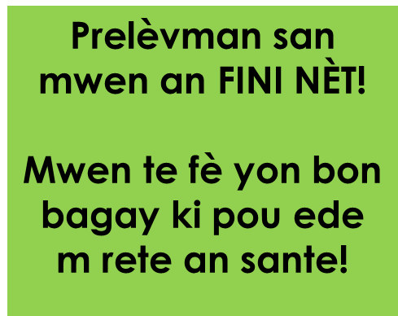

About this initiative:

This social story and associated tools are part of a clinical initiative to improve access to blood draws for individuals with neurodevelopmental disabilities, such as Autism Spectrum Disorder (ASD). This initiative additionally includes a caregiver tip sheet and blood draw toolkit with physical materials to practice a blood draw at home, as well as necessary collaboration with medical providers and accommodation within a medical setting. This comprehensive approach is designed to address the unique needs of patients with ASD and enhance their overall experience. The development of this social story, as well as other preventative care social stories was made possible through the Healthcare Access for Autism Project funded by the C.J.L. Foundation.

Spearheading this transformative project is a multidisciplinary team, Dr. Jill Pineda, psychologist, and Stef Barnard, RN at the Lurie Center for Autism at Mass General Brigham for Children. Dr. Pineda and Stef Barnard’s dedication to advancing autism care is driven by their commitment to equitable healthcare and extensive experience working with individuals with autism across the lifespan.

