SOCIAL STORY:

Blood Draw: What I need to Know

Healthcare Access for Autism Project​ Made possible by the C.J.L. Foundation
A note to caregivers:

This social story is intended to support your loved one in completing a blood draw at Mass General Hospital or any other clinic or hospital setting. The steps may vary depending on your loved one’s medical history and needs. As such, not all sections may apply to your loved one. For any specific concerns, please reach out to your medical provider to discuss prior to your loved one’s procedure.

You know your loved one the best. This social story was created as a tool to aid in preparing an individual for their upcoming blood draw. We recommend that you read this first and choose what information you think will be helpful. Please feel free to use and modify this in conjunction with language and other tools your loved one is familiar with. For instance, the phrase “First Blood Draw, Then Home” may be modified to include a different location or enjoyable activity that could be done after the blood draw is complete. Please modify images of relevant doctors, support persons, and coping strategies to ensure it is individualized to your loved one’s needs.

Some tips for preparation and use of the social story include the following:

- Review in advance. Plan to review the social story for yourself or with your loved one well in advance of the blood draw. This allows time to process expectations, identify possible challenges, and problem solve ways to help decrease anxiety.
- Individualize. Every individual may need or prefer different amounts of information, so decide what information is most helpful to you/your loved one. Add pictures or information that is specific to you/your loved one (e.g. picture of doctor, support person, preferred distractions). There are several areas throughout the story where information can be edited and personalized. For individuals with more cognitive or communication challenges, consider using slides 4-6, 14,17 – 32.
- Identify Coping Strategies. Look for coping strategies that are outlined in orange throughout the story. Identify tools that may be helpful to decrease anxiety. Distraction is the number one strategy to decrease anxiety around medical procedures.
- Advocate. You know yourself/your loved one’s needs the best. Advocate for what you need to make the blood draw successful. Sometimes this may include using visual supports to show each step, scheduling at a less busy time to reduce wait time, not using a band-aid, asking a physician to order anxiety medication and/or EMLA cream to numb the skin, and setting a limit for when to take a break or stop a blood draw if you/your loved are experiencing significant anxiety or behaviors that make the experience unsafe (e.g. grabbing at the needle).​ Consider making a list of questions for your doctor/medical team that you/your loved one have about the blood draw or related outcomes.
- Review and practice. Make an effort to review what will happen during the blood draw. Look at the steps of the blood draw and determine what aspects of the procedure may lead to increased anxiety. This can inform strategies that could be helpful (e.g. using distraction during steps that cause more anxiety, using adhesive wrap rather than a band-aid, wearing short sleeves).​ Practice the steps of the blood draw in advance. Become familiar with the materials (e.g. tourniquet, gloves, alcohol wipe, butterfly needle with needle removed and replaced with a paperclip) and practice the steps that will happen during the real blood draw. ​ Take small, gradual steps when practicing to allow your loved one to become more comfortable while increasing familiarity with the materials that will be involved in the blood draw. ​Practice holding still for approximately 3 minutes, using a timer to serve as a reminder to hold still.

For some, it can additionally be helpful to practice modifications of these steps at home or come for a pre-visit tour. We understand that coming to the doctor and undergoing a procedure can be stressful. Please bring any comfort items you feel your child would benefit from.

We are committed to ensuring both you and your loved one have the best experience possible. Please do not hesitate to let us know how we can best support you and your loved one.

Sincerely,

Lurie Center Team

I will be going to get my blood draw at

___________________________________
(location)

on

_____________________.
(date)



(Insert picture of location)

I may feel nervous, but it’s okay because my family member/caregiver will go with me.

I will not be alone.

________________ will come with me.


(insert picture of support person)

First, I will get my blood drawn, then I will go home.

FIRST  BLOOD DRAW | THEN  HOME  OR ____________________  (insert preferred activity)
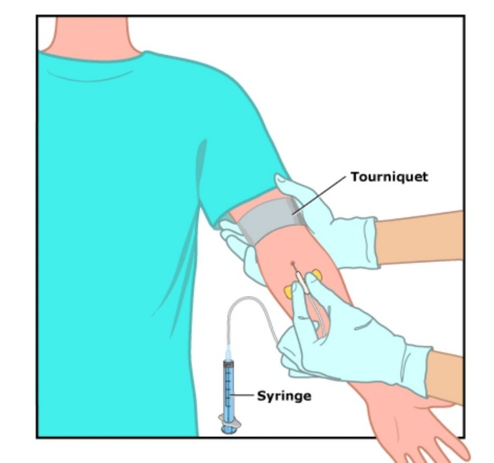
Why do I need a blood draw?

A blood draw is recommended by doctors about 1 time per year.

It is an important procedure that tells the doctor more about my body to make sure I am healthy.

Doctors and scientists collect blood in a tube.

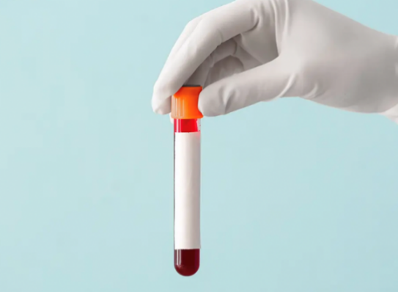
Different cells in our bodies have different functions that impact how our body works.

I can learn more about blood draws at:

- What You Need to Know About Blood Testing: MedlinePlus Medical Test
- Blood Draw Video
A blood draw can provide more information for my doctor to help me, like finding out if I need to take medicine.

Make a diagnosis   | Explain symptoms, like feeling tired or sick  
Find out if medicine or treatment is helping   | Monitor my health or health condition  
Find out if I need to change my diet or take medicine


I may feel nervous or scared. This is normal.
If I am feeling scared, I can:

Tell someone how I am feeling | Ask my nurse or doctor a question | Take a deep breath
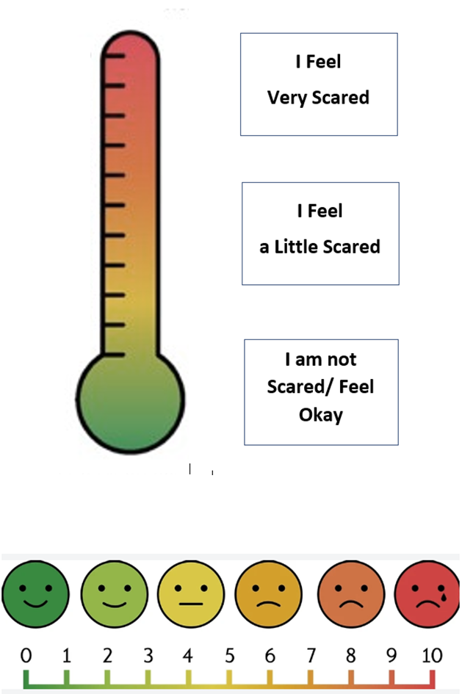 |  | 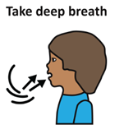
Think of something fun I will do when I am done | Watch a video or look at pictures | ____________  (insert other)
 | 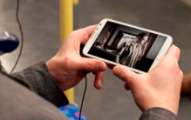

I can tell someone how I am feeling.

How do I prepare for a blood draw?

Before my blood draw it is important for me to review what will happen.

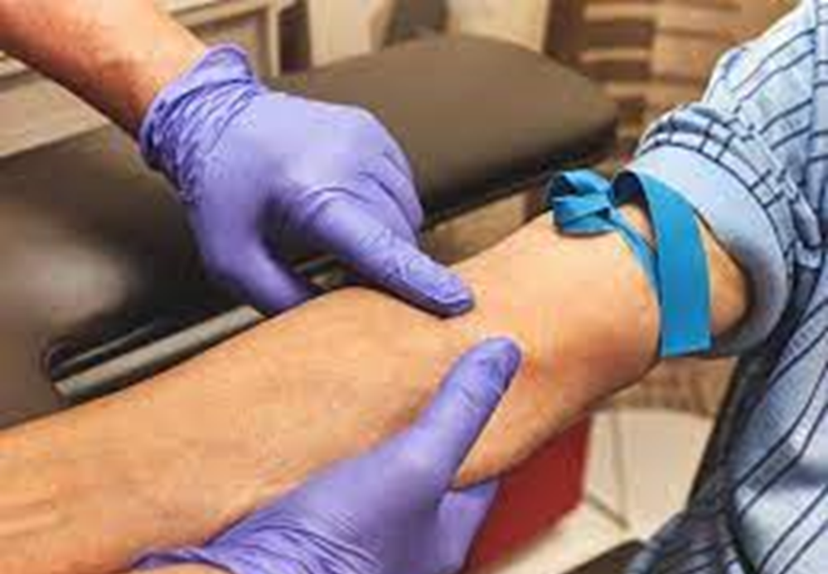

To get ready for my test, I can look at pictures and watch videos of blood draws.

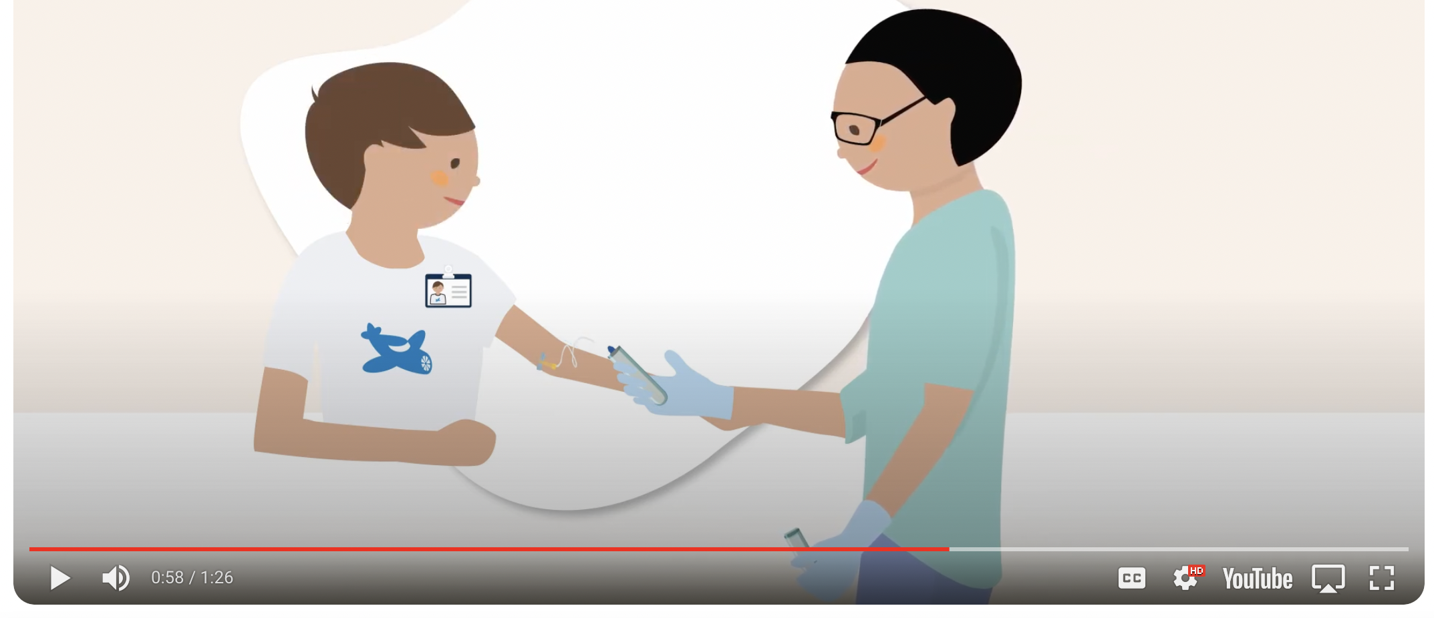
Blood Draw Video

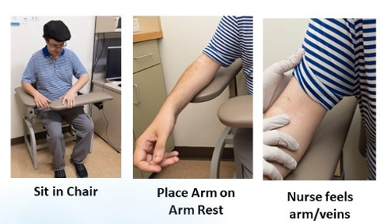 | 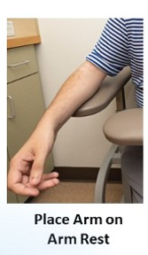
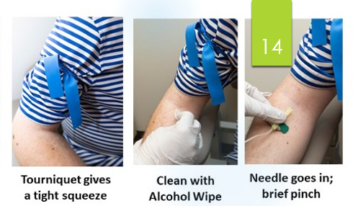
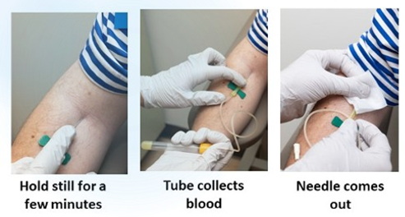
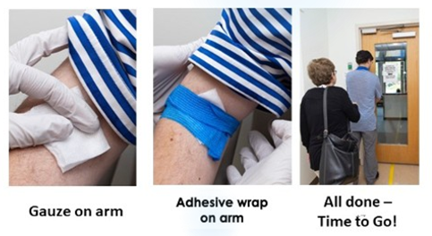
I can look at the pictures and talk about how I might feel during each step of the blood draw – not at all nervous, a little nervous, or very nervous.

Talking about how I feel can help me and my family/caregiver make a plan.

If I am nervous about:
Rolling up my sleeve | I can wear short sleeves  
The tourniquet | I can practice and remind myself “It gives my arm a hug.”
Seeing the needle | I can look away  
Band aid | I can ask for an adhesive wrap that doesn’t stick to my skin

Next, I could look at pictures of the place I will go to get my blood drawn.





Sometimes, I might be able to visit the place before my blood draw to help me feel ready.

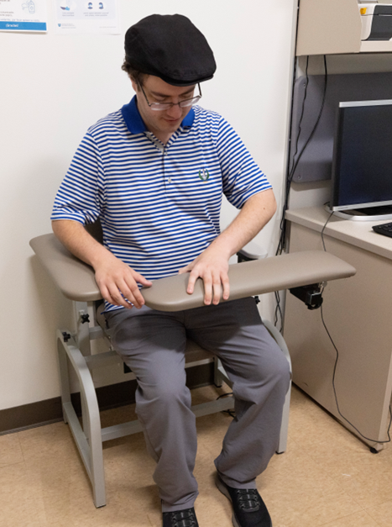

If I practice a blood draw at home, I may feel less scared or nervous.

I can practice on a family member or friend and have them practice on me.

I will need to practice holding still for approximately 3 minutes.

A timer can help me remember how long I need to hold still.


(Visual Countdown Timer)
There are several things I can do to get ready for the day of the blood draw.

I can:
  Drink plenty of water |   Wear short sleeves
  Bring a support person | 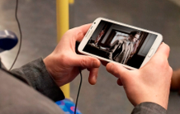    Bring Distractions

Ask my doctor if I need medicine and/or numbing cream
If I have questions, I can write them down and ask my doctor, nurse, or phlebotomist before my blood draw.



Questions I would like to ask my doctor/nurse:
1.

2.

3.

What happens the day of my blood draw?

On the day of the blood draw, I will go to the clinic to complete my blood draw.



I will walk in and check in at the front desk. I can bring a support person to help me feel comfortable.

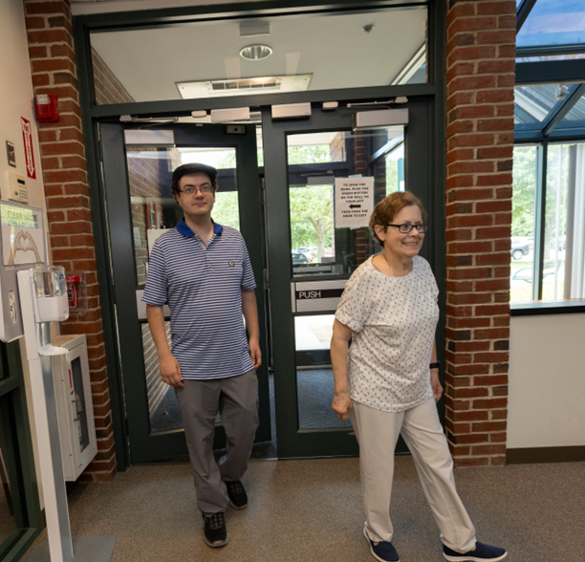

I will wait in the waiting room until my name is called.



I can bring something to do while I wait.

When the nurse calls my name, I will walk back to the exam room and can bring my support person if I want.

I will sit down in the blood draw chair. I can let my nurse know if I have questions.

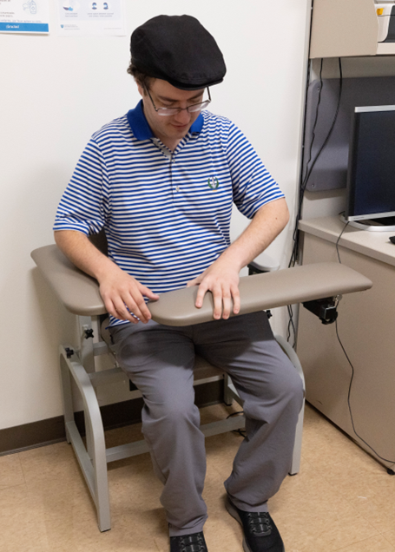
I can start to enjoy the things I brought for distractions.

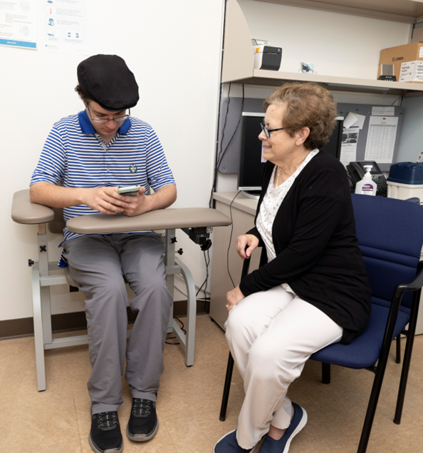

I should lay my arm on the chair so the nurse can look at and feel my veins.

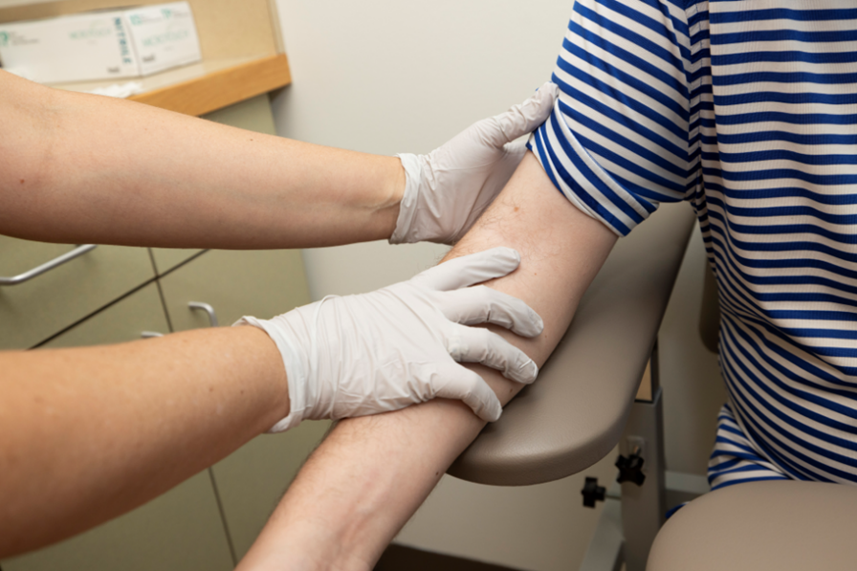

The nurse will put on gloves and then tie the tourniquet on my arm. The tourniquet gives my arm a hug and feels like a tight squeeze.



The nurse will clean my arm with an alcohol wipe.


It may feel wet and cold and will have a strong smell.

The nurse will put the needle in my arm. It will feel like a brief pinch or pain.

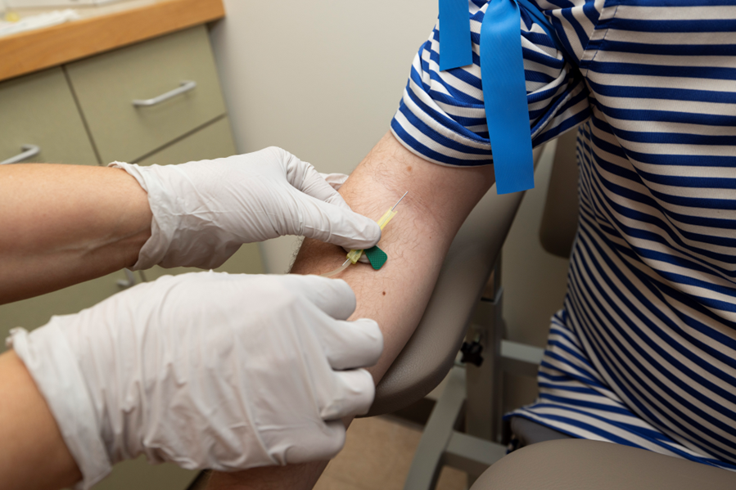
If I feel nervous, I can:

Tell someone how I am feeling | Ask my nurse or doctor a question | Take a deep breath
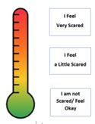
Think of something fun I will do when I am done | Watch a video or look at pictures | Look away from the needle


I can also hold my support person’s hand if I want.

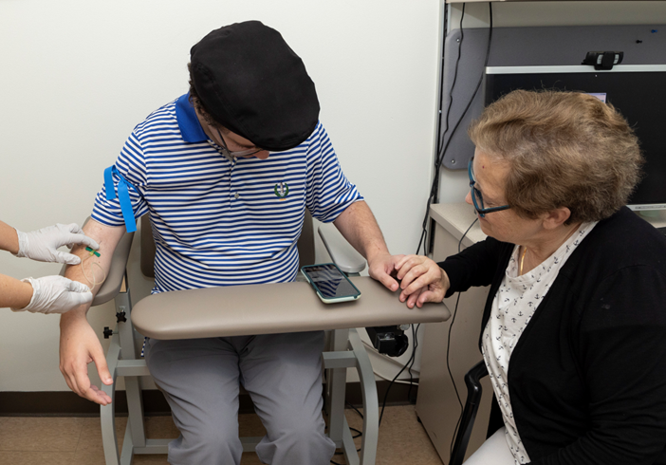

I will hold still for about 3 minutes. It will be done quickly. I can use a timer to remind me how long I need to hold still.

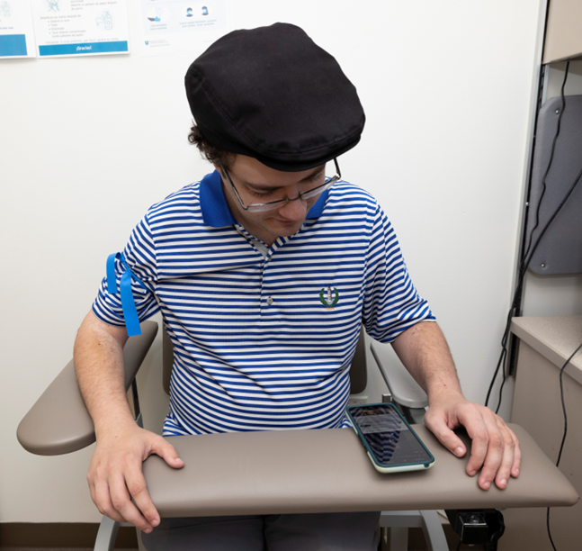
My nurse will take off my tourniquet. After a short time, my nurse will take out the needle. I am almost done!

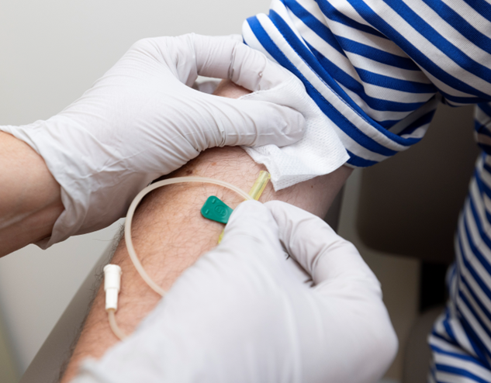

My nurse or phlebotomist will put gauze and an adhesive wrap or a band aid on my arm.

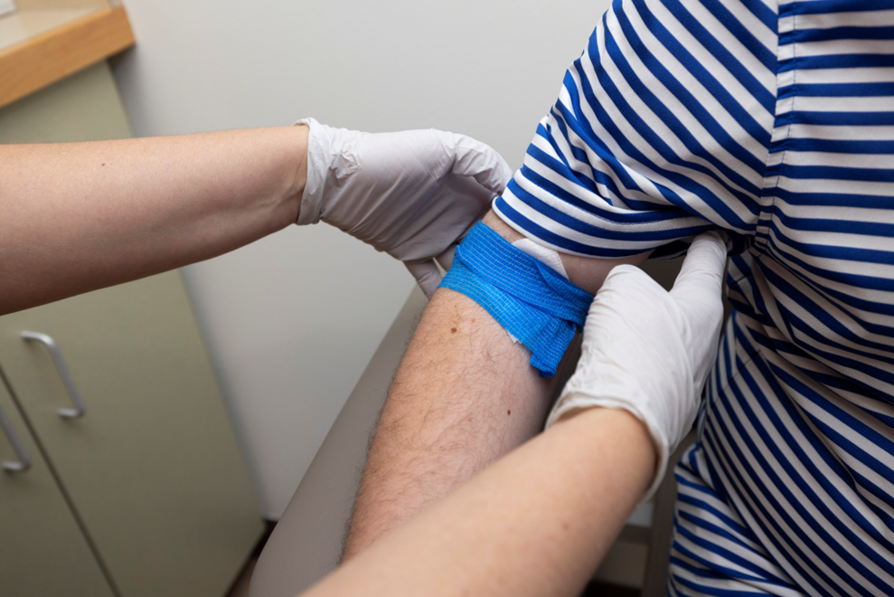

I am all done and ready to go!

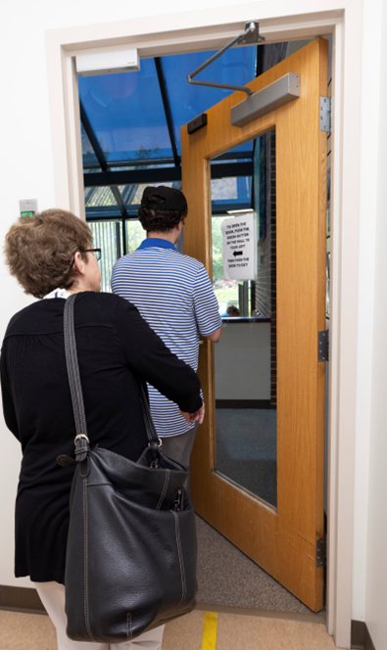

It is great I did something to keep me healthy and strong!

My blood draw is ALL DONE!
It was good I did something that helps me to stay healthy!

My doctor, ______________________, will talk to me and my family about the results and tell me what I need to know.



About this initiative:

This social story and associated tools are part of a clinical initiative to improve access to blood draws for individuals with neurodevelopmental disabilities, such as Autism Spectrum Disorder (ASD). This initiative additionally includes a caregiver tip sheet and blood draw toolkit with physical materials to practice a blood draw at home, as well as necessary collaboration with medical providers and accommodation within a medical setting. This comprehensive approach is designed to address the unique needs of patients with ASD and enhance their overall experience. The development of this social story, as well as other preventative care social stories was made possible through the Healthcare Access for Autism Project funded by the C.J.L. Foundation.

Spearheading this innovative project is a multidisciplinary team, Dr. Jill Pineda, psychologist, and Stef Barnard, RN at the Lurie Center for Autism at Mass General Brigham for Children. Dr. Pineda and Stef Barnard’s dedication to advancing autism care is driven by their commitment to equitable healthcare and extensive experience working with individuals with autism across the lifespan.



